Welcome to Water Bug ISR, LLC!
Featuring
INFANT SWIMMING RESOURCE, LLC
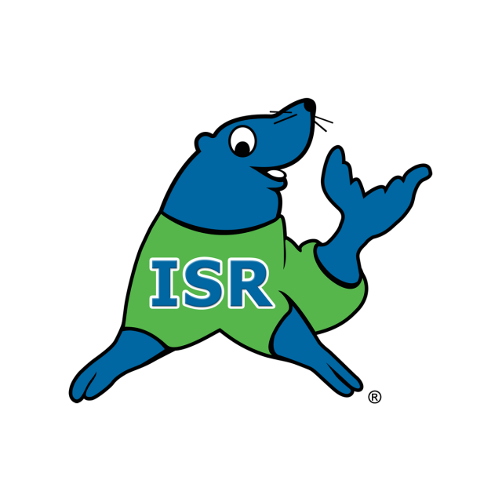
The finest aquatic self-rescue instruction for infants and children
Congratulations on enrolling your child in lessons with Infant Swimming Resource (ISR), the safest and most effective self-rescue instruction available. To ensure your child receives the full benefit of the program, please review and follow the policies and guidelines below:
The ISR Mission:
“Not one more child drowns”

Before Lessons Begin
- Read the Parent Resource Guide
Every family received a digital copy in the ISR National Office approval letter. Please read it thoroughly—this is essential information!

Pre-Lesson Nutrition
- Avoid dairy and high-fat foods for at least 2 hours before lessons, and do not feed your child anything within 1 hour of the lesson. These guidelines help prevent abdominal distention caused by gas. Refer to the Parent Resource Guide for a list of foods to avoid.

Daily Procedures
- Poolside BUDS Sheet
This are questions that will be completed daily to help monitor and safeguard your child's health.
- Towels
Please bring three (3) clean, dry towels daily for each child:
- Two towels create a sanitary barrier poolside.
- One towel is used to dry and warm your child after the lesson.

Arrival & Timing
- Arrive early so your child is ready to enter the pool at the scheduled time. Lessons run promptly, and late arrivals will not receive extended time. Consistency benefits every child!

Swim Diapers
- Children who are not toilet-trained must wear *two reusable* swim diapers. Disposable swim diapers are not permitted. (An example of a great one here.)

Your Role as a Parent
- You are your child’s biggest supporter! Please do not give verbal instructions during lessons. Follow the instructor’s cues for when to offer praise—this keeps your child focused and helps reinforce proper learning.
- Cameras are welcome only on Fridays. Please keep phones away during all other lessons.
- Diaper Disposal: As a courtesy to the facility and others, please take soiled diapers home for disposal.

Attendance & Make-Ups
- You are reserving a weekly lesson time. Regular attendance is expected for all students—both new and returning.
- Missed lessons will not be made up unless cancelled by the instructor. Any allowed make-up time will be used for maintenance lessons at the end of the session.
- Tuition is non-refundable for missed lessons—no exceptions.

Health & Wellness
- Inform your instructor immediately of any doctor visits, illnesses, or vaccinations.
- If your child experiences fever, vomiting, or diarrhea, they must be symptom-free for 48 hours before returning.
- After vaccinations, a 12-hour waiting period is required before resuming lessons.

Swimming Outside of Lessons
- Due to the structure of the ISR program, recreational swimming during the session is discouraged. Unsupervised swimming can interfere with ISR training and lead to undesirable water behaviors.
Thank you for your cooperation and commitment. Let’s make this a safe, successful, and enjoyable experience for your child!

